# Introduction to Amazon Elastic Compute Cloud Lab

Table of Contents

Lab Overview 3

Lab Objectives 3

Task 1: Launch Your Amazon EC2 Instance 4

Task 2: Monitor the Amazon EC2 Instance 10

Task 3: Update the Security Group and Access to the Web Server 12

Task 4: Resize Your Instance: Instance Type and EBS Volume 14

Task 5: Test Termination Protection 16

Conclusion 18

Reference 19

## Lab Overview

This lab provided me with a basic overview of launching, resizing, managing, and monitoring an Amazon EC2 instance.

Amazon Elastic Compute Cloud (Amazon EC2) is a web service that provides resizable compute capacity in the cloud (AWS,2025). This is designed to make web-scale cloud easier for developers.

The Amazon EC2’s simple web service interface allows users to obtain and configure capacity with minimal friction (AWS,2025). It provides users with complete control of the computing resources and runs on Amazon’s proven computing environment.

Amazon EC2 changes the economics of computing by allowing users to pay for the service and capacity they use. Amazon EC2 provides developers with the tools to build failure-resilient applications and isolate themselves from common failure scenarios (AWS,2025).

## Lab Objectives

By the end of this lab, I was able to do the following:

* Launched a web server with termination protection enabled.
* Monitor the EC2 instance
* Modify the security group that the web server is using to allow HTTP access.
* Resize the Amazon EC2 instance to scale.
* Test termination protection.
* Terminate the EC2 instance.

### Task 1: Launch Your Amazon EC2 Instance

In this task, I launched an Amazon EC2 instance with termination protection. The protection prevents accidental termination of the EC2 instance. The instance has the User Data script that installs a simple web server.

* Step 1: Search for and choose EC2

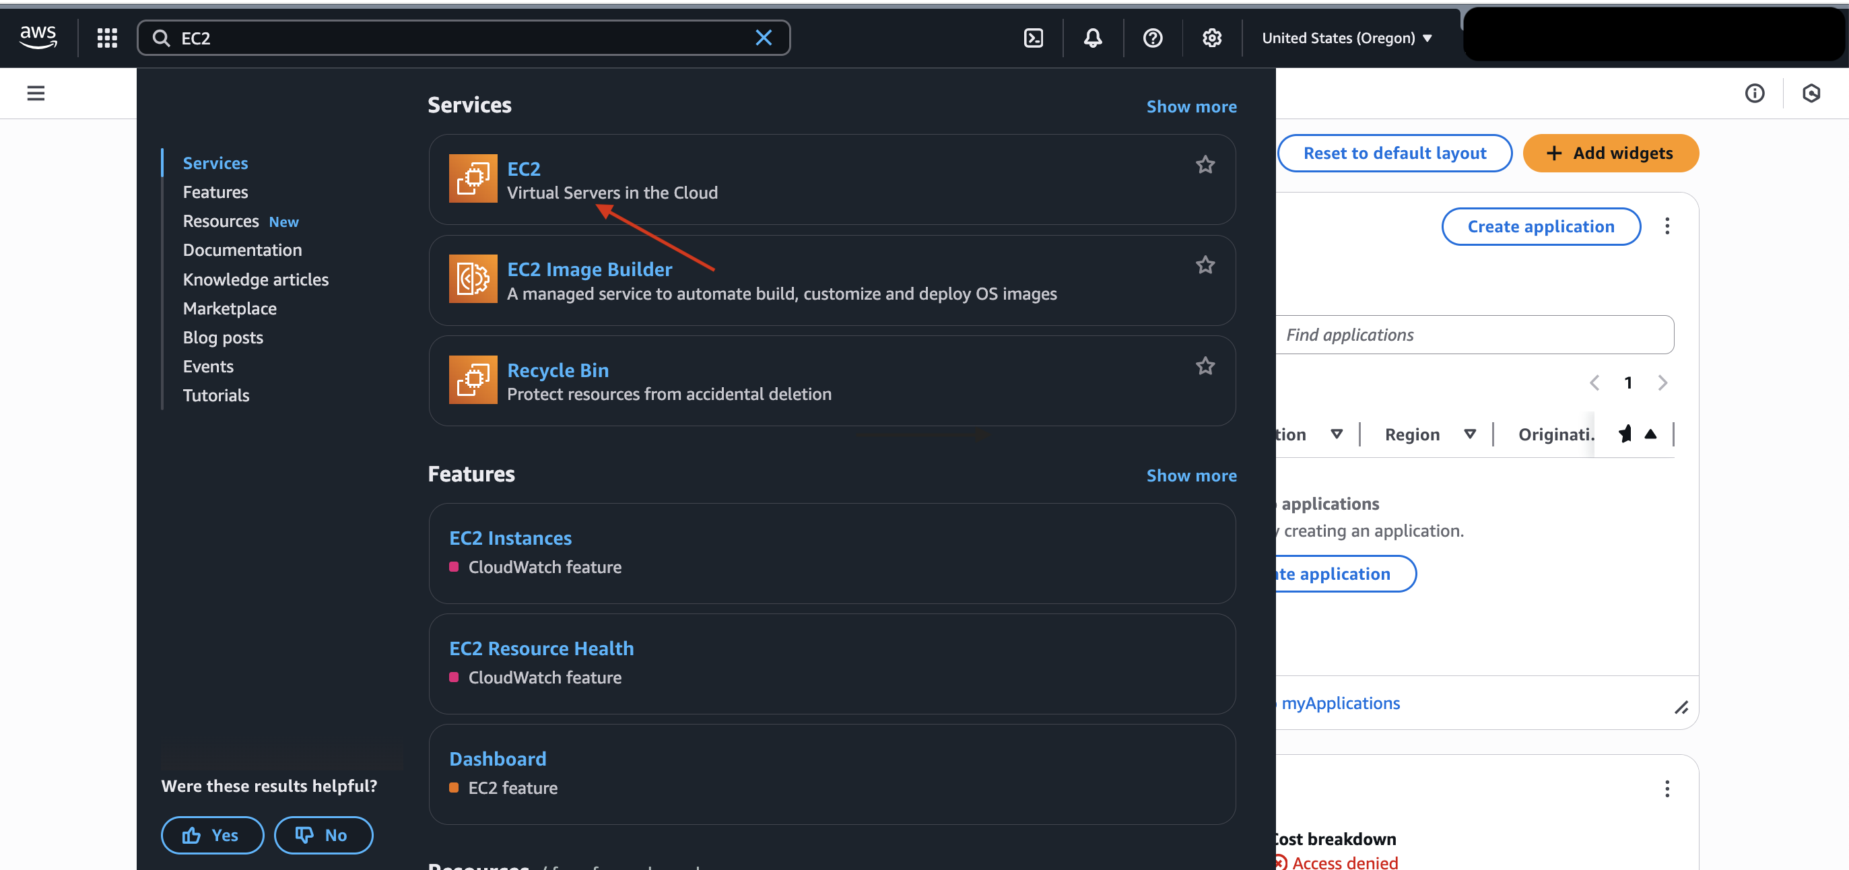

Figure 1: EC2 search (source: personal collection)

* In the EC2 dashboard, I launched a new instance as follows:

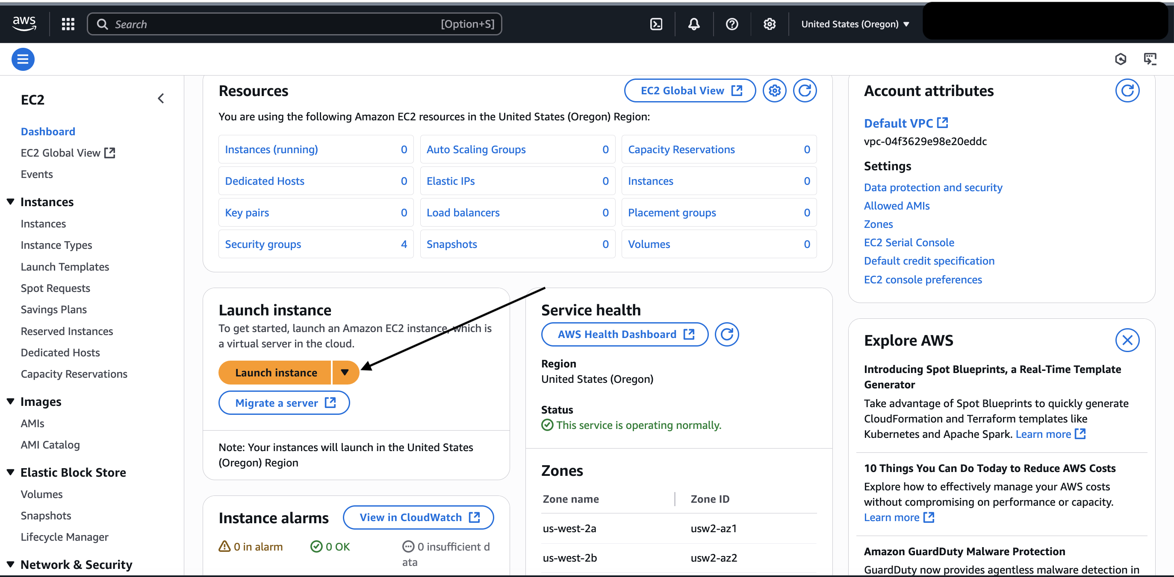

Figure 2: EC2 Dashboard (source: personal collection)

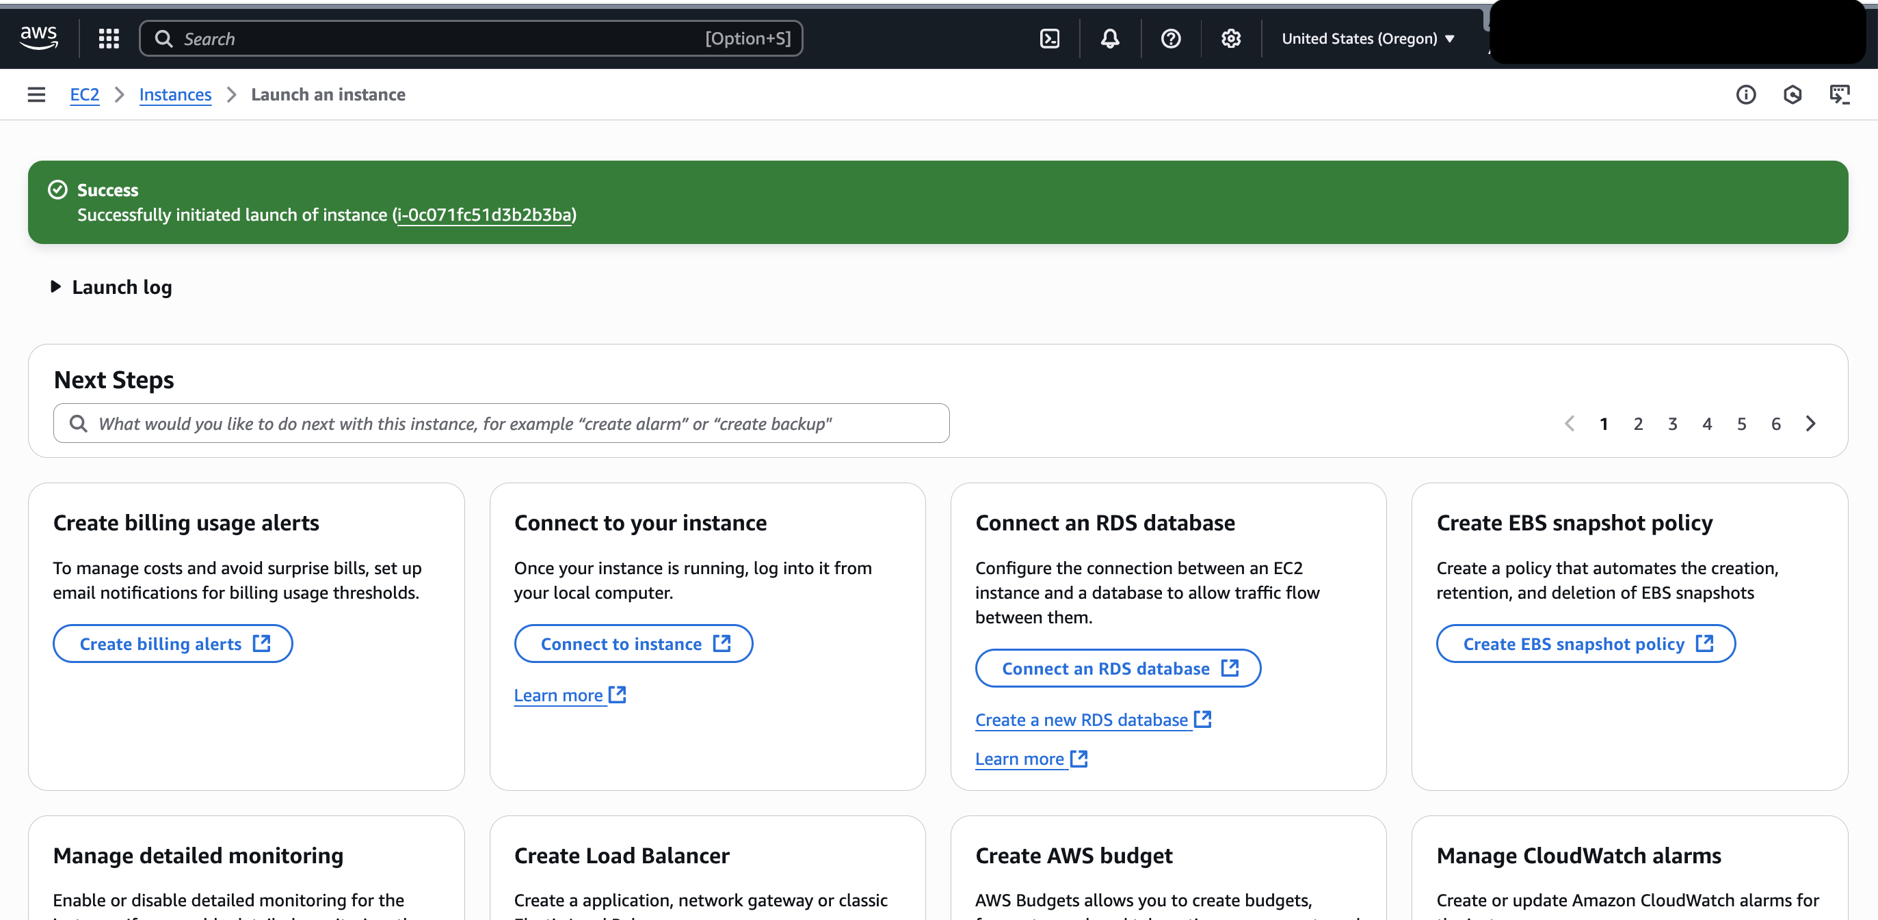

Figure 3: EC2 launched (source: personal collection)

* Step 2: I selected the Amazon Machine Image (AMI): Amazon Linux 2023 kernel-6.1 AMI

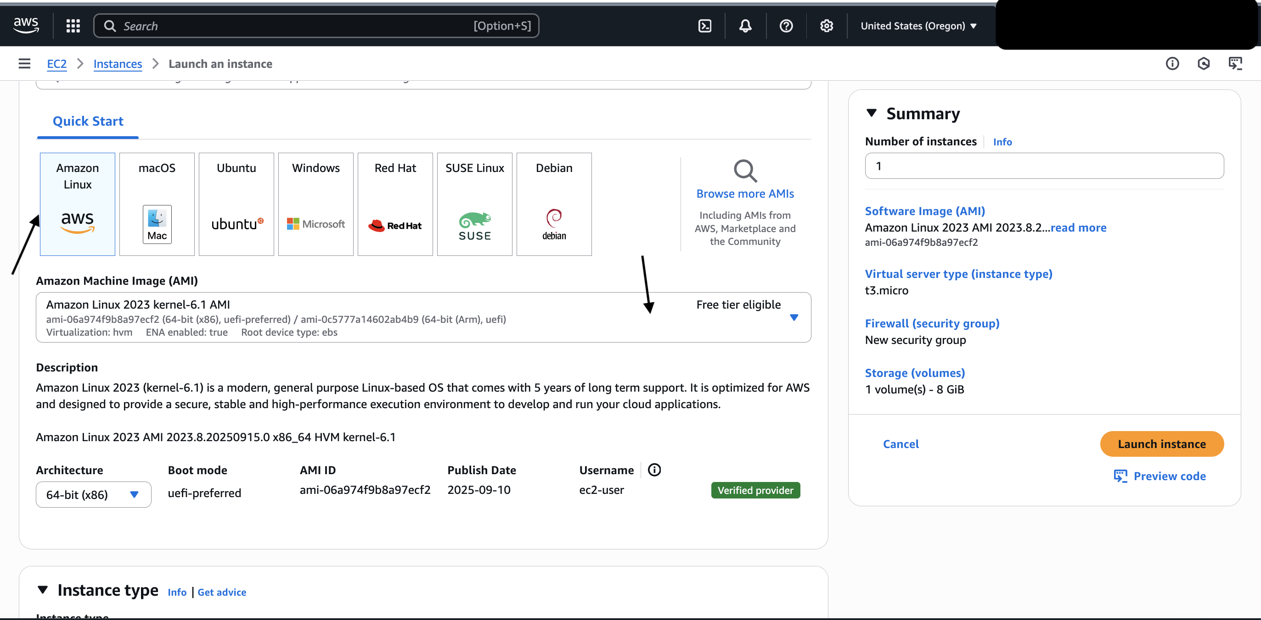

Figure 4: AMI overview (source: personal collection)

* Step 3: I selected the instance type “t3. micro” in the drop-down menu as follows:

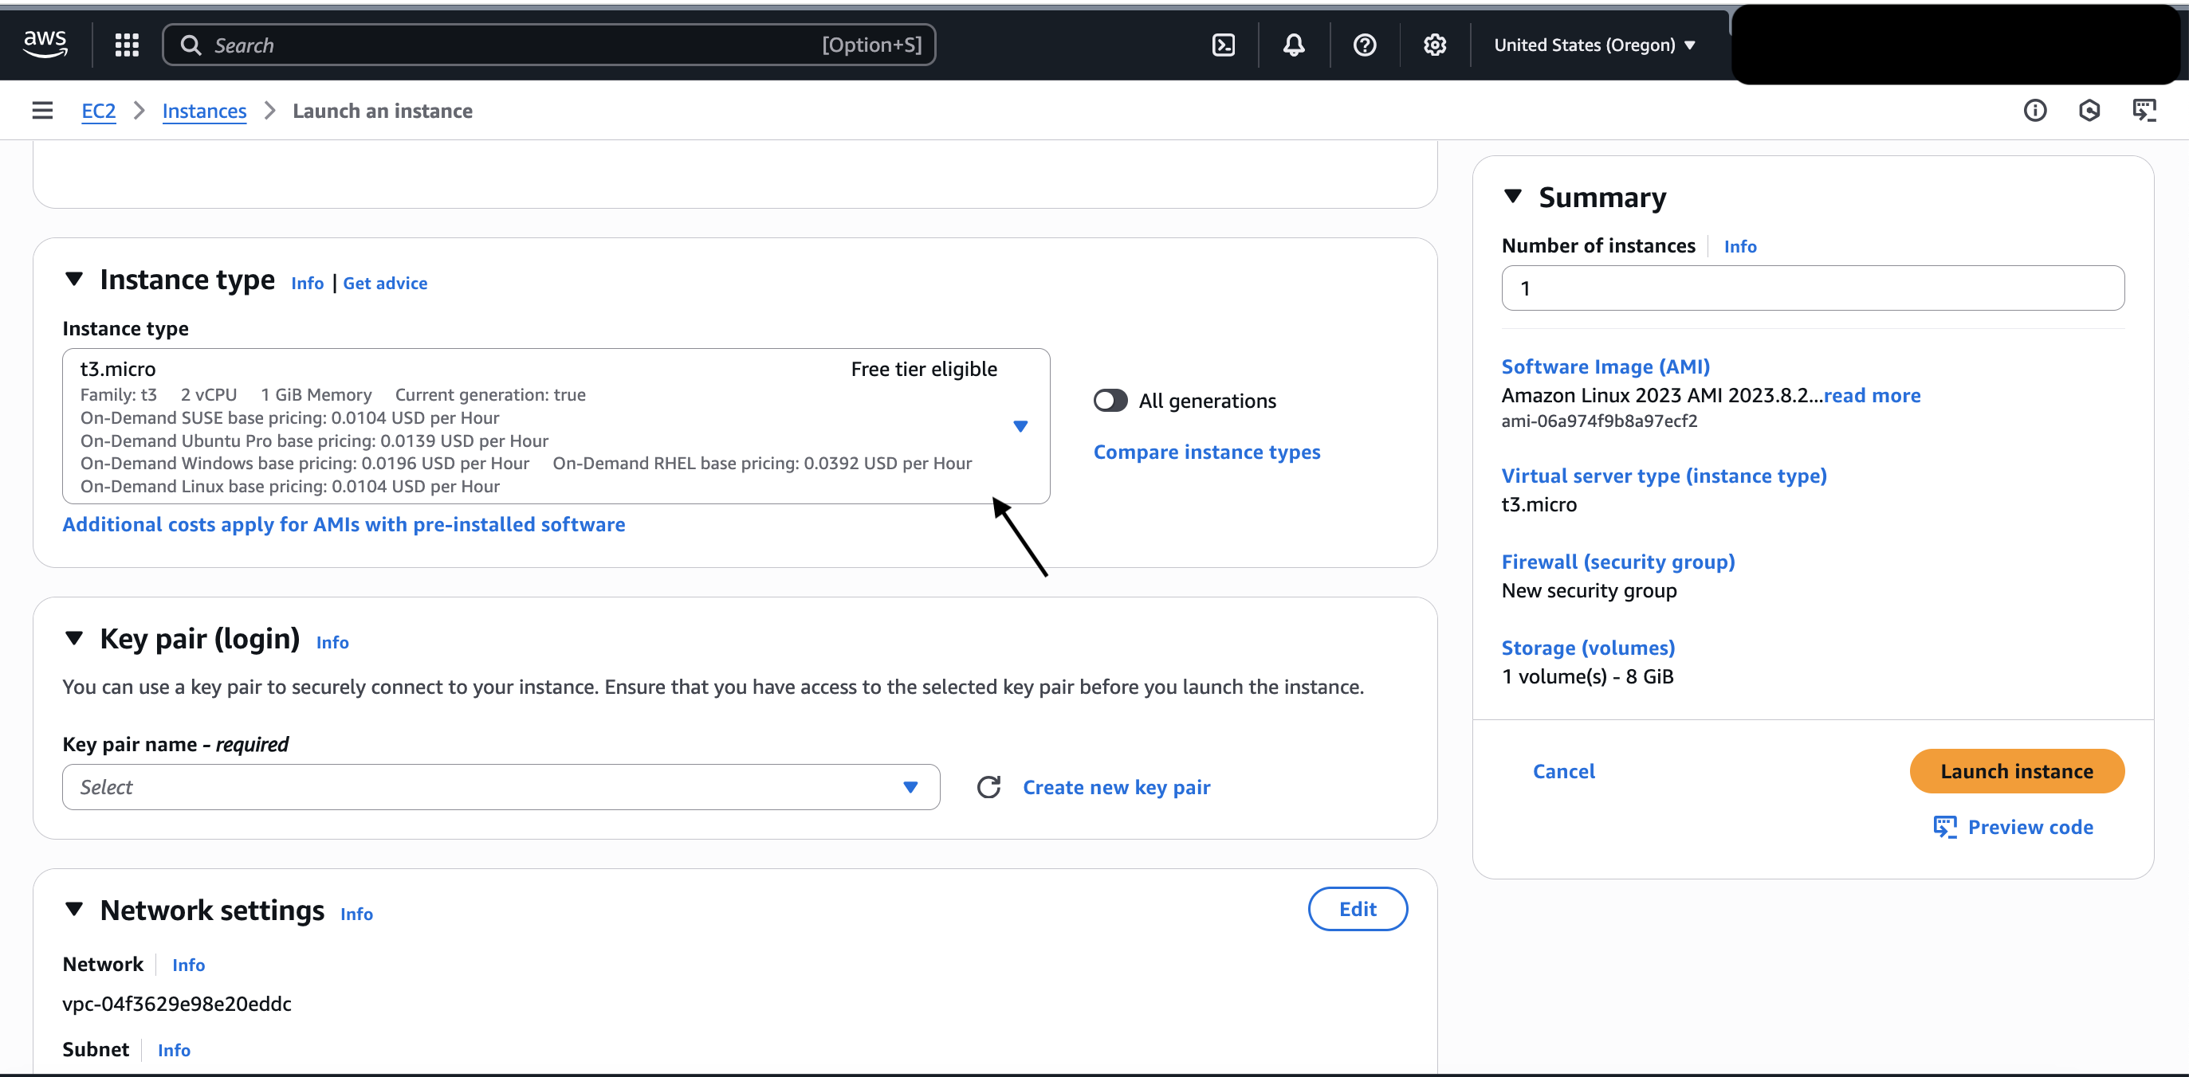

Figure 5: selecting t3. micro instance (source: personal collection)

Note: a t3. Micro has 2 virtual CPUs and 1 GiB of memory.

* Step 4: Select the key pair (login) “Proceed without a key pair (Not recommended)”

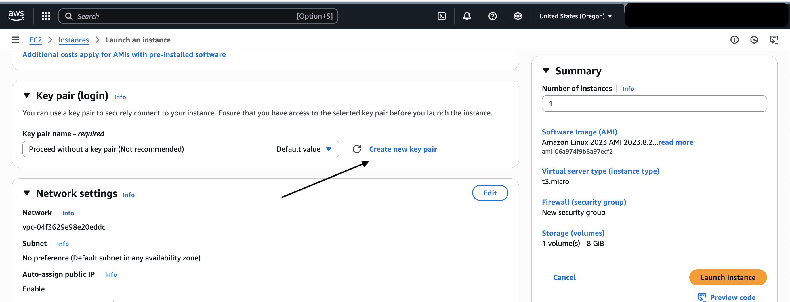

Figure 6: Key pair name (source: personal collection)

* Configuring the network settings as follows:

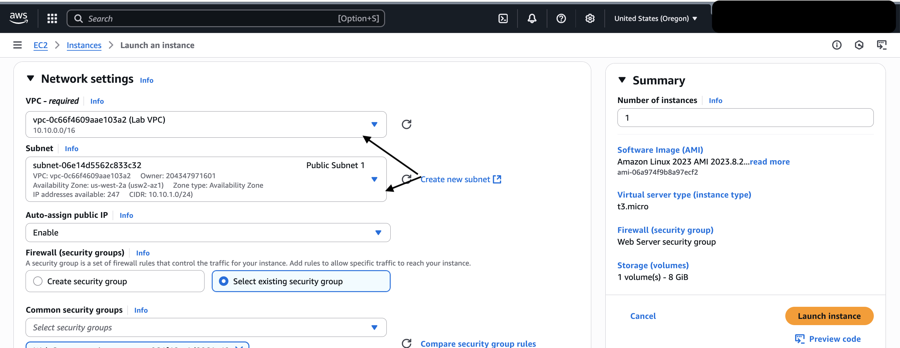

Figure 7: Network settings overview (source: personal collection)

* The network settings include:
  + The VPC name “Lab VPC”
  + The Subnet “Public Subnet 1”
  + The common security groups “Web Server security group”

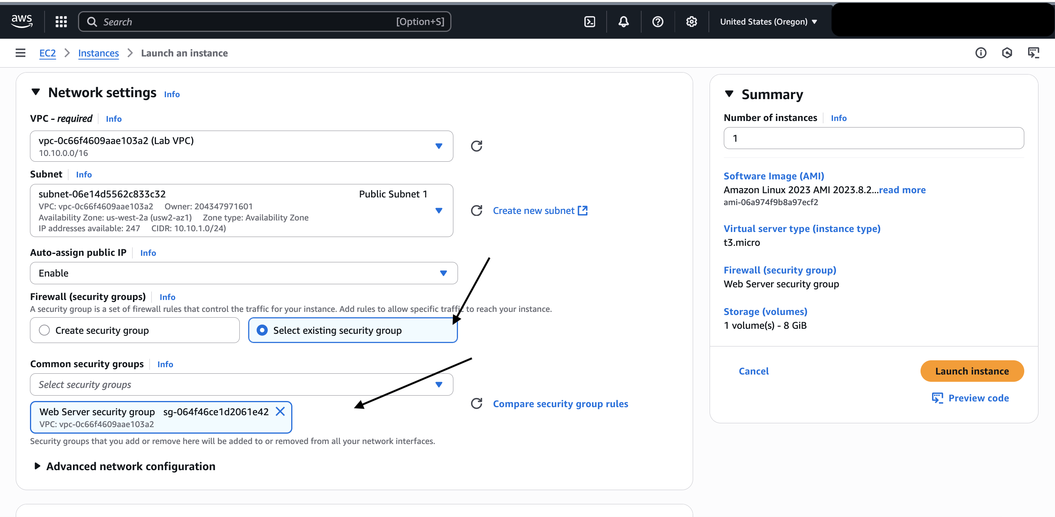

Figure 8: Security group overview (source: personal collection)

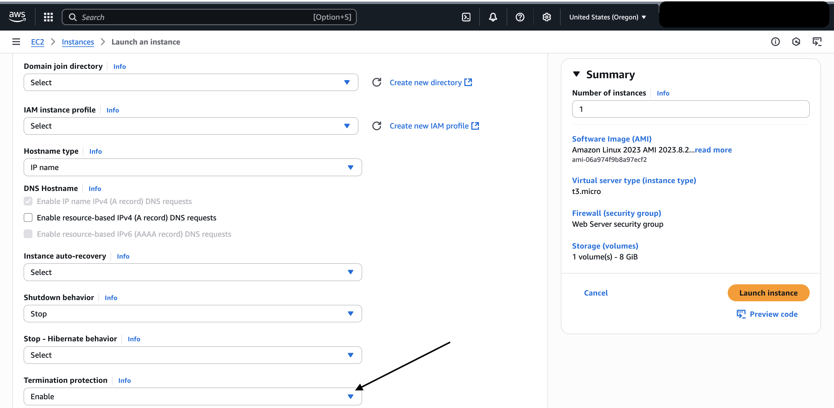

Figure 9: enabling termination protection (source: personal collection)

* Step 5: I provisioned a shell script that runs when the instance starts as follows:

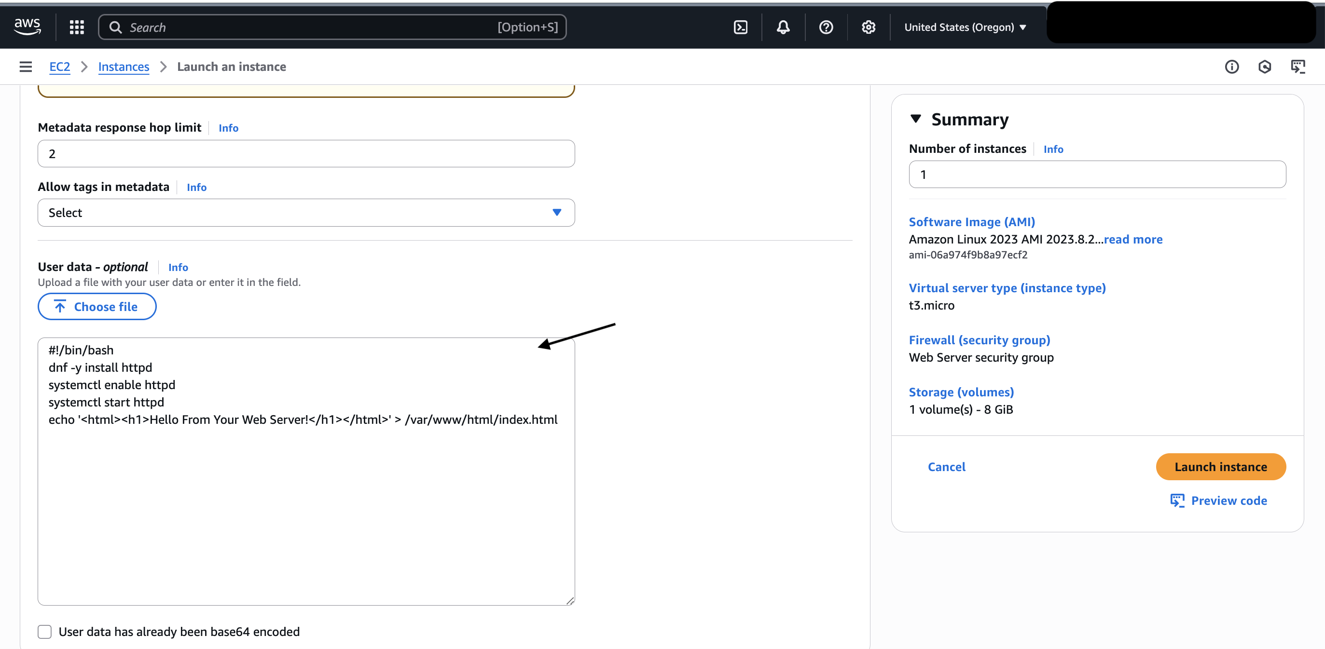

Figure 10: Script writing (source: personal collection)

Note: the script installed the following:

* + Apache Web Server (httpd)
  + Web server automatic booting
  + Web server activation
  + Simple web page creation
* Step 6: I finally launched the instance successfully as follows:

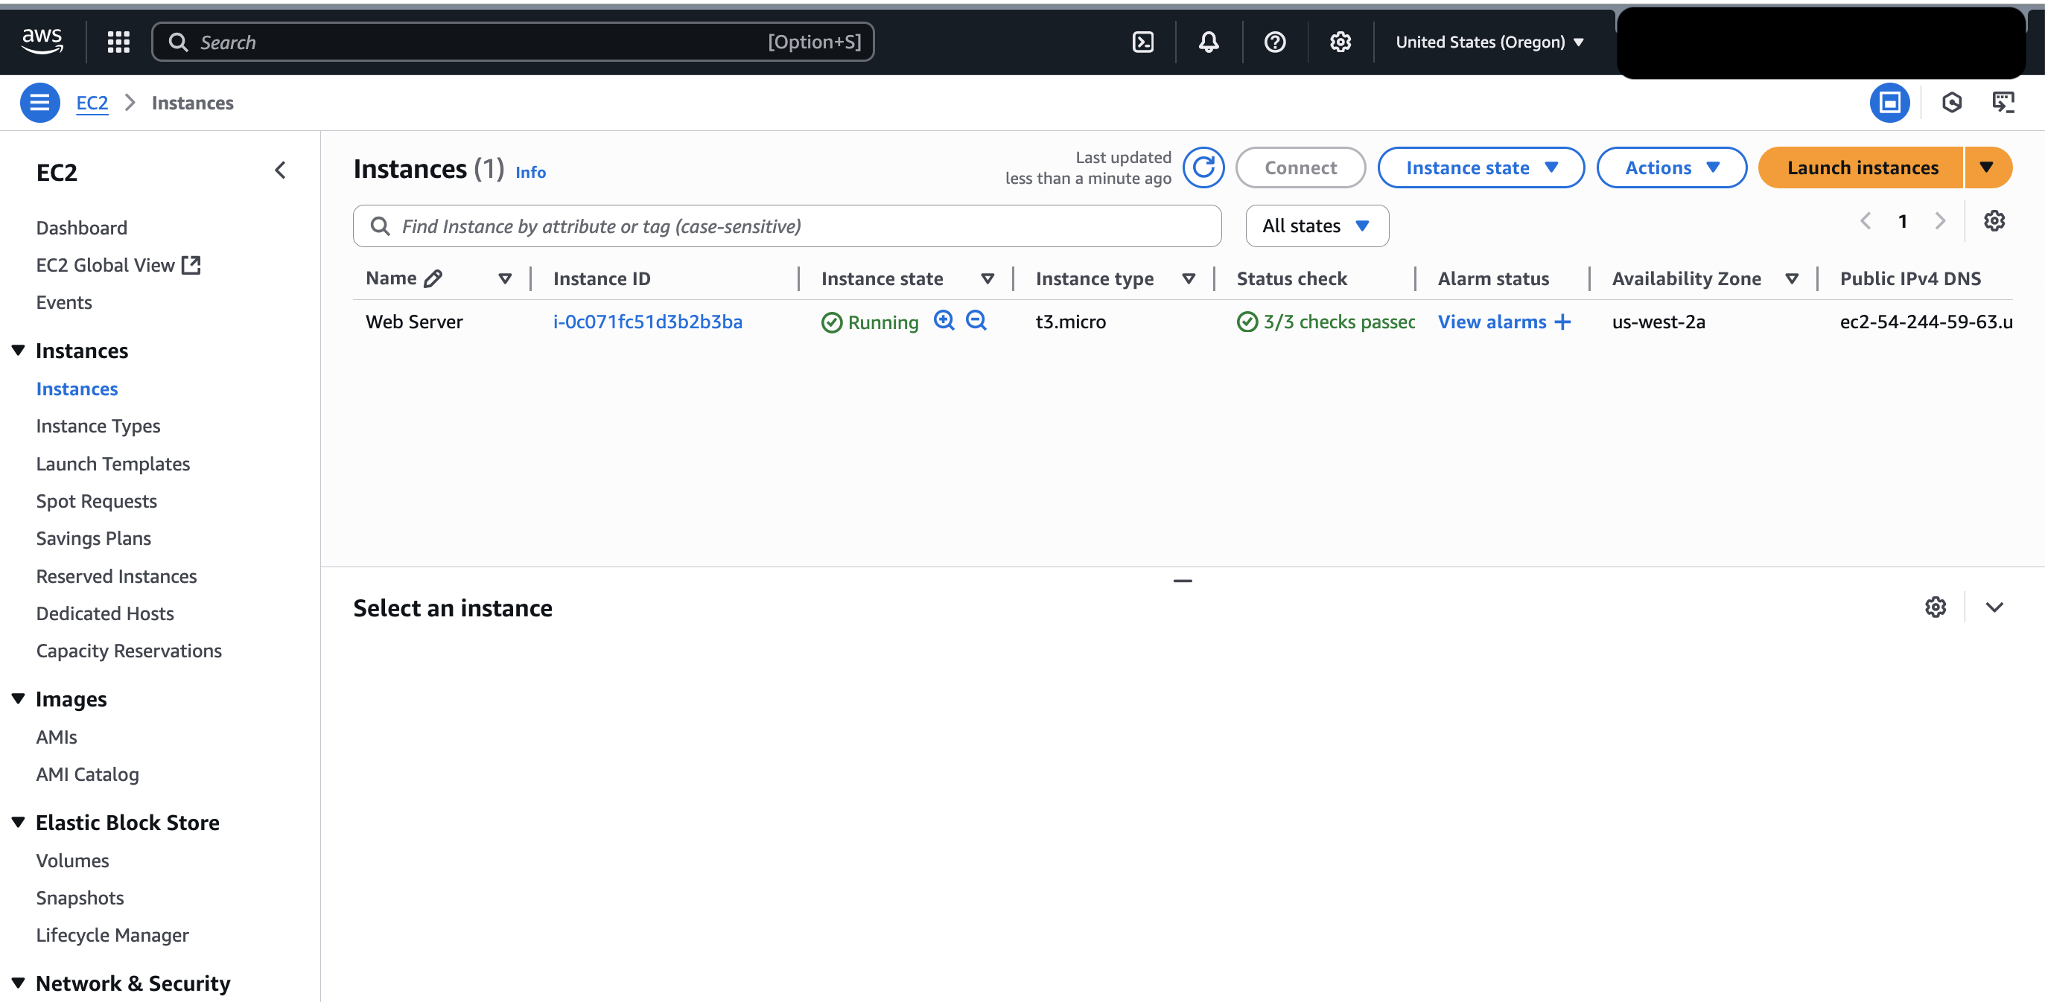

Figure 11: Instance running (source: personal collection)

### Task 2: Monitor the Amazon EC2 Instance

This is an important part of ensuring the reliability, availability, and performance of the Amazon Elastic Compute Cloud (Amazon EC2) instances and the AWS solutions (AWS,2025).

* Step 1: From the action drop down, I selected the option “Monitor and troubleshoot” as follows:

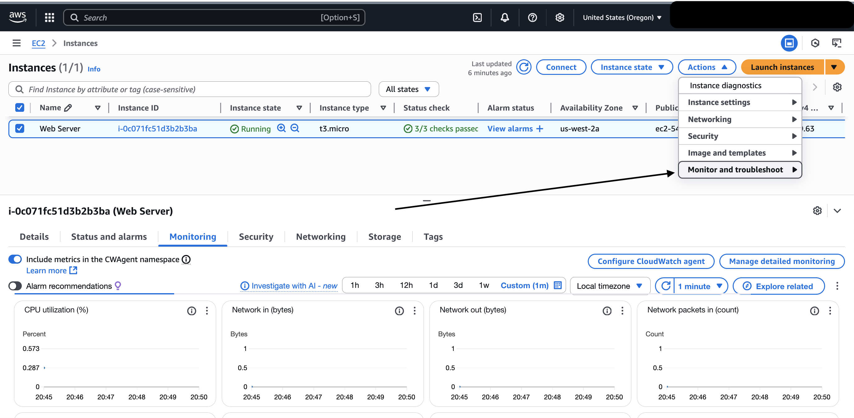

Figure 12: Monitor and troubleshoot (source: personal collection)

* Step 2: I viewed the system log from the “Get system log” as follows:

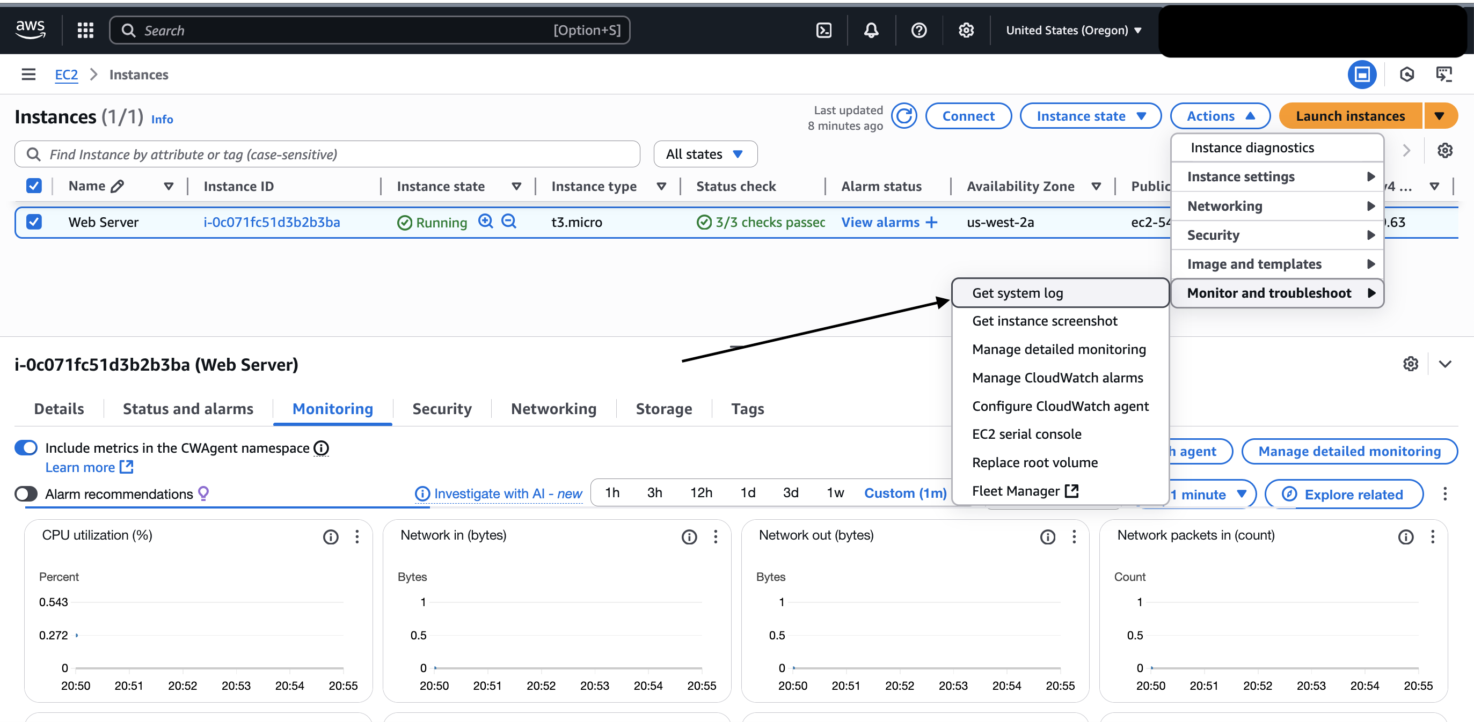

Figure 13: Get system log (source: personal collection)

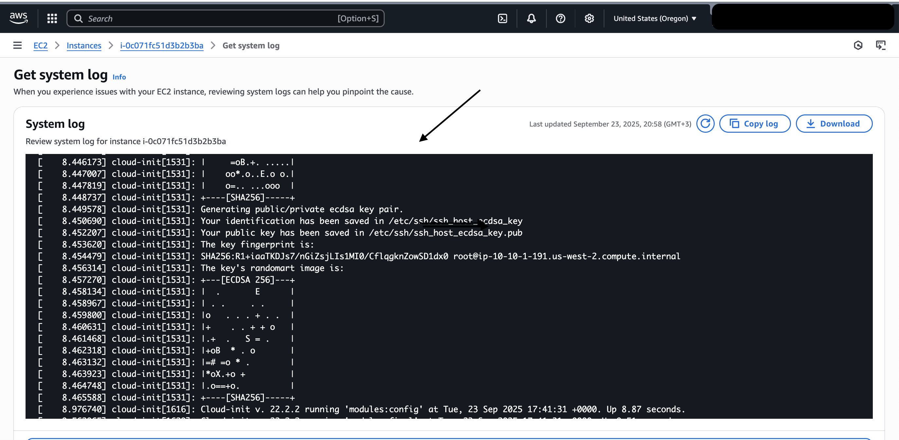

Figure 14: System log results (source: personal collection)

* Step 3: from the “Monitor and troubleshoot” I selected the “Get instance screenshot” as follows:

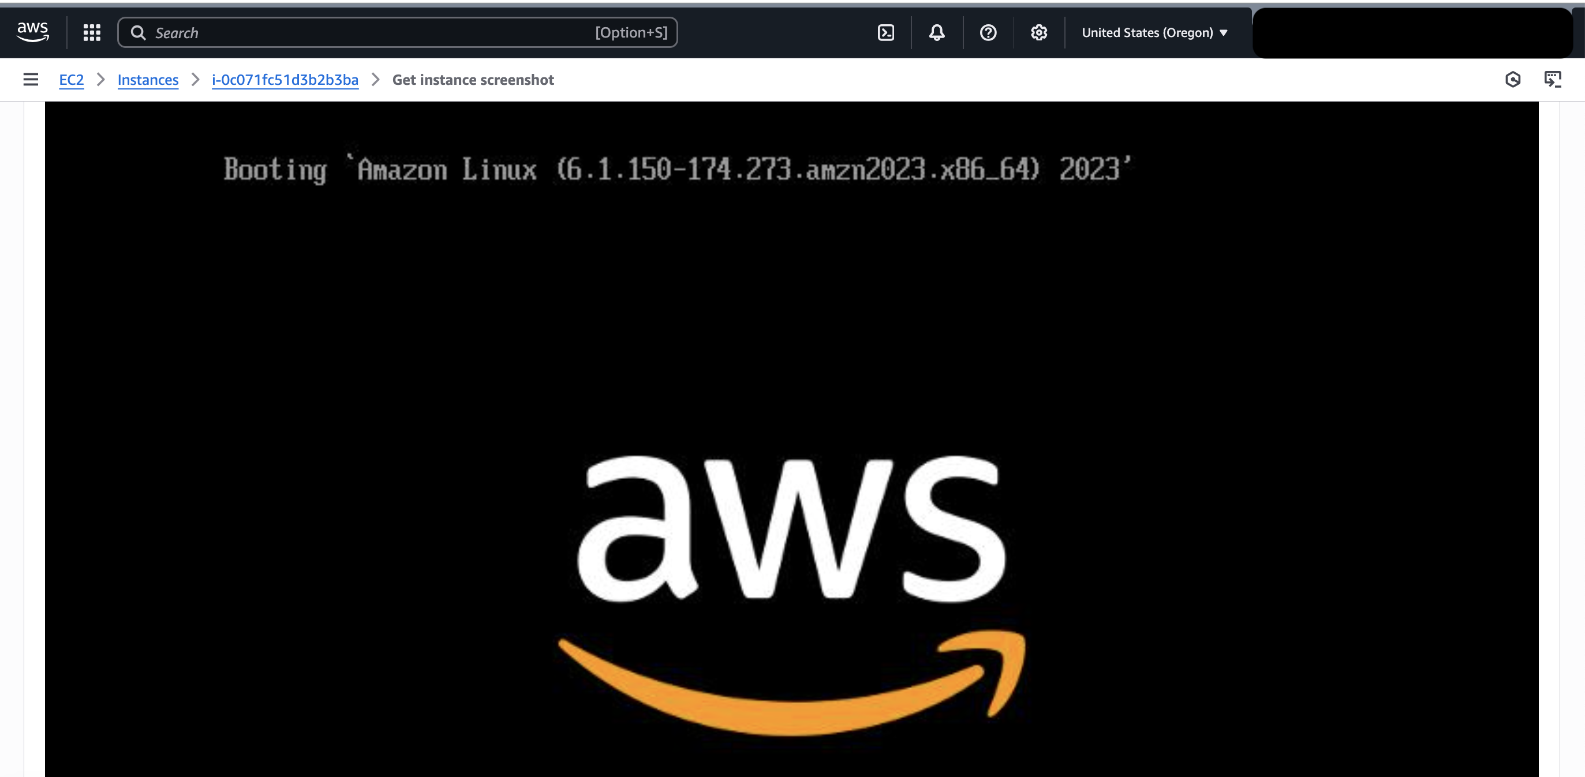

Figure 15: instance screenshot (source: personal collection)

### Task 3: Update the Security Group and Access to the Web Server

* Step 1: from the checkbox next to the “Web Server”, I accessed the “Details tab”, copied the public IPv4 address, and pasted it into my web browser as follows:

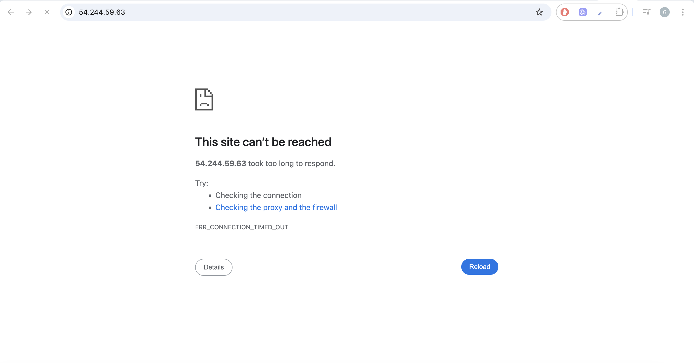

Figure 16: Connection error from the browser (source: personal collection)

* Step 2: I set up the inbound rule to allow access to the internet as follows:

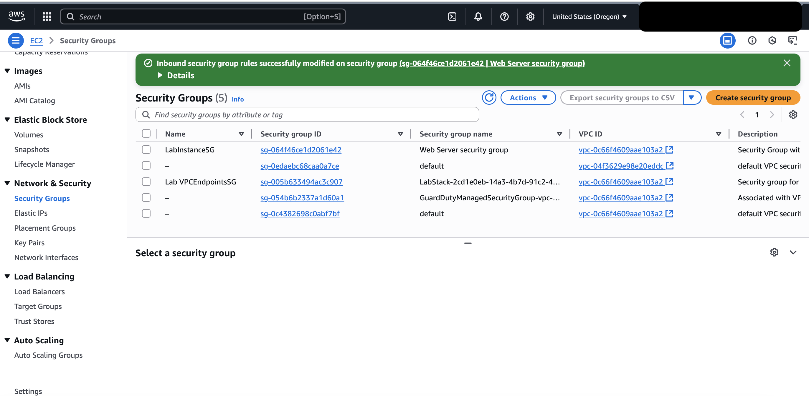

Figure 17: inbound rule creation (source: personal collection)

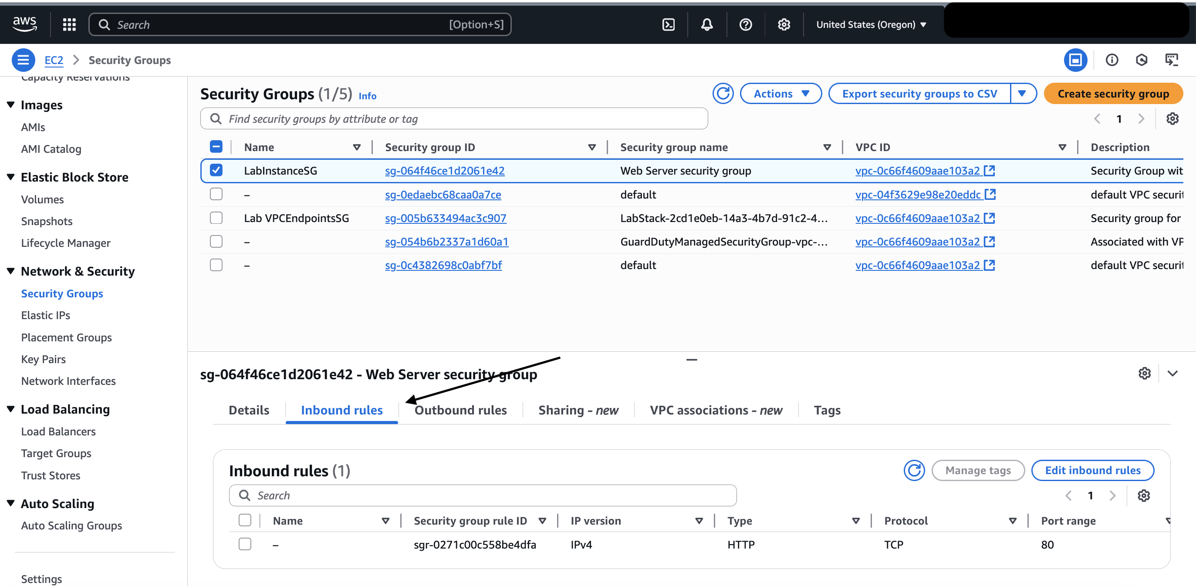

Figure 18: inbound rule details (source: personal collection)

* Step 3: I successfully relaunched the web server as follows:

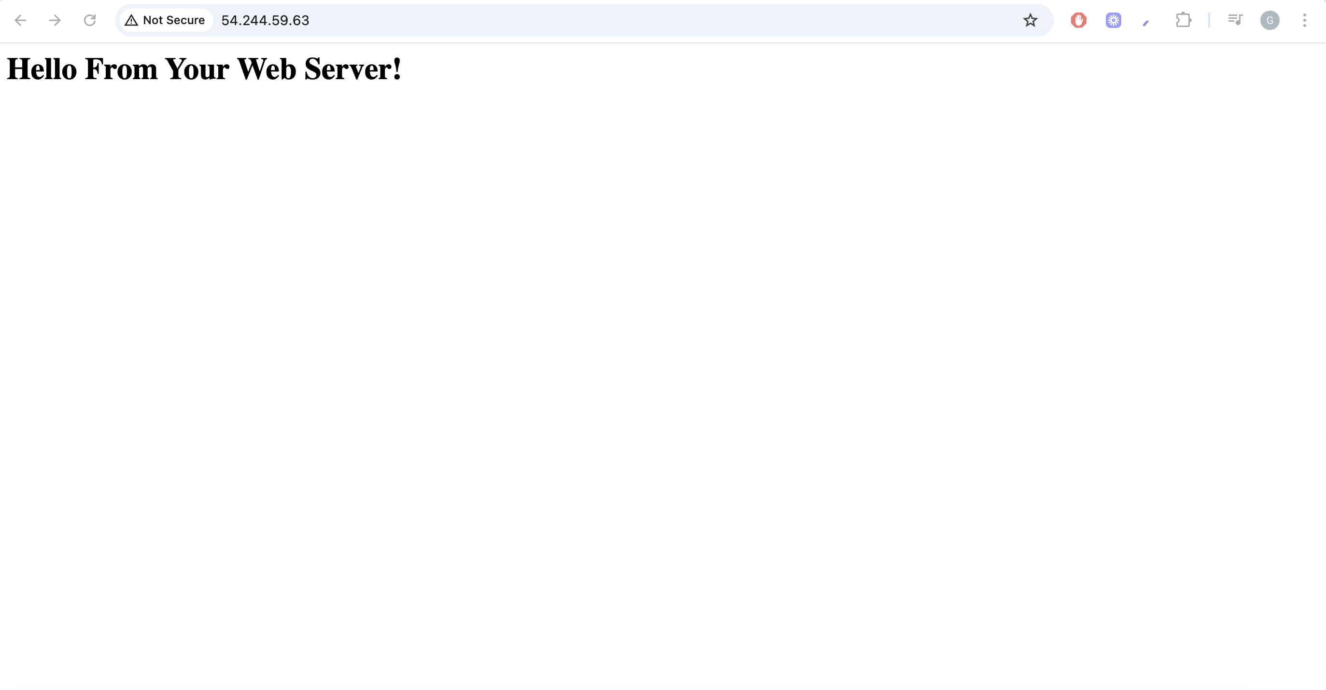

Figure 19: Web server launched (source: personal collection)

### Task 4: Resize Your Instance: Instance Type and EBS Volume

### In this task, I changed the instance type from t3. Micro to t3. Small, and the disk size is from 8 GiB to 10 Gi[1]B.

* Step 1: Stopping the instance as follows:

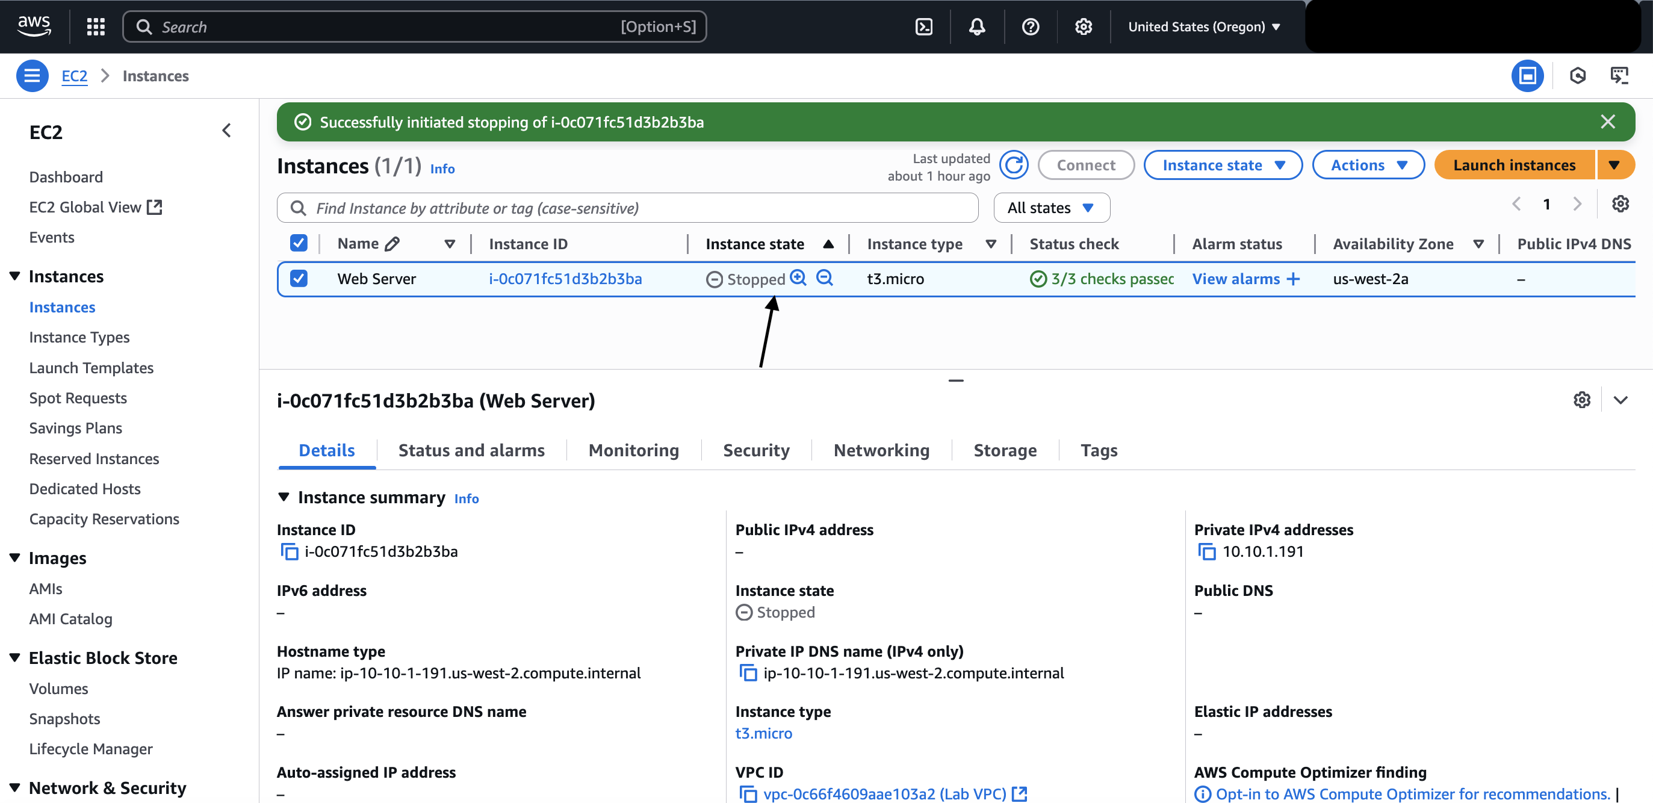

Figure 20: stopped instance (source: personal collection)

* Step 2: I changed the instance type as follows:

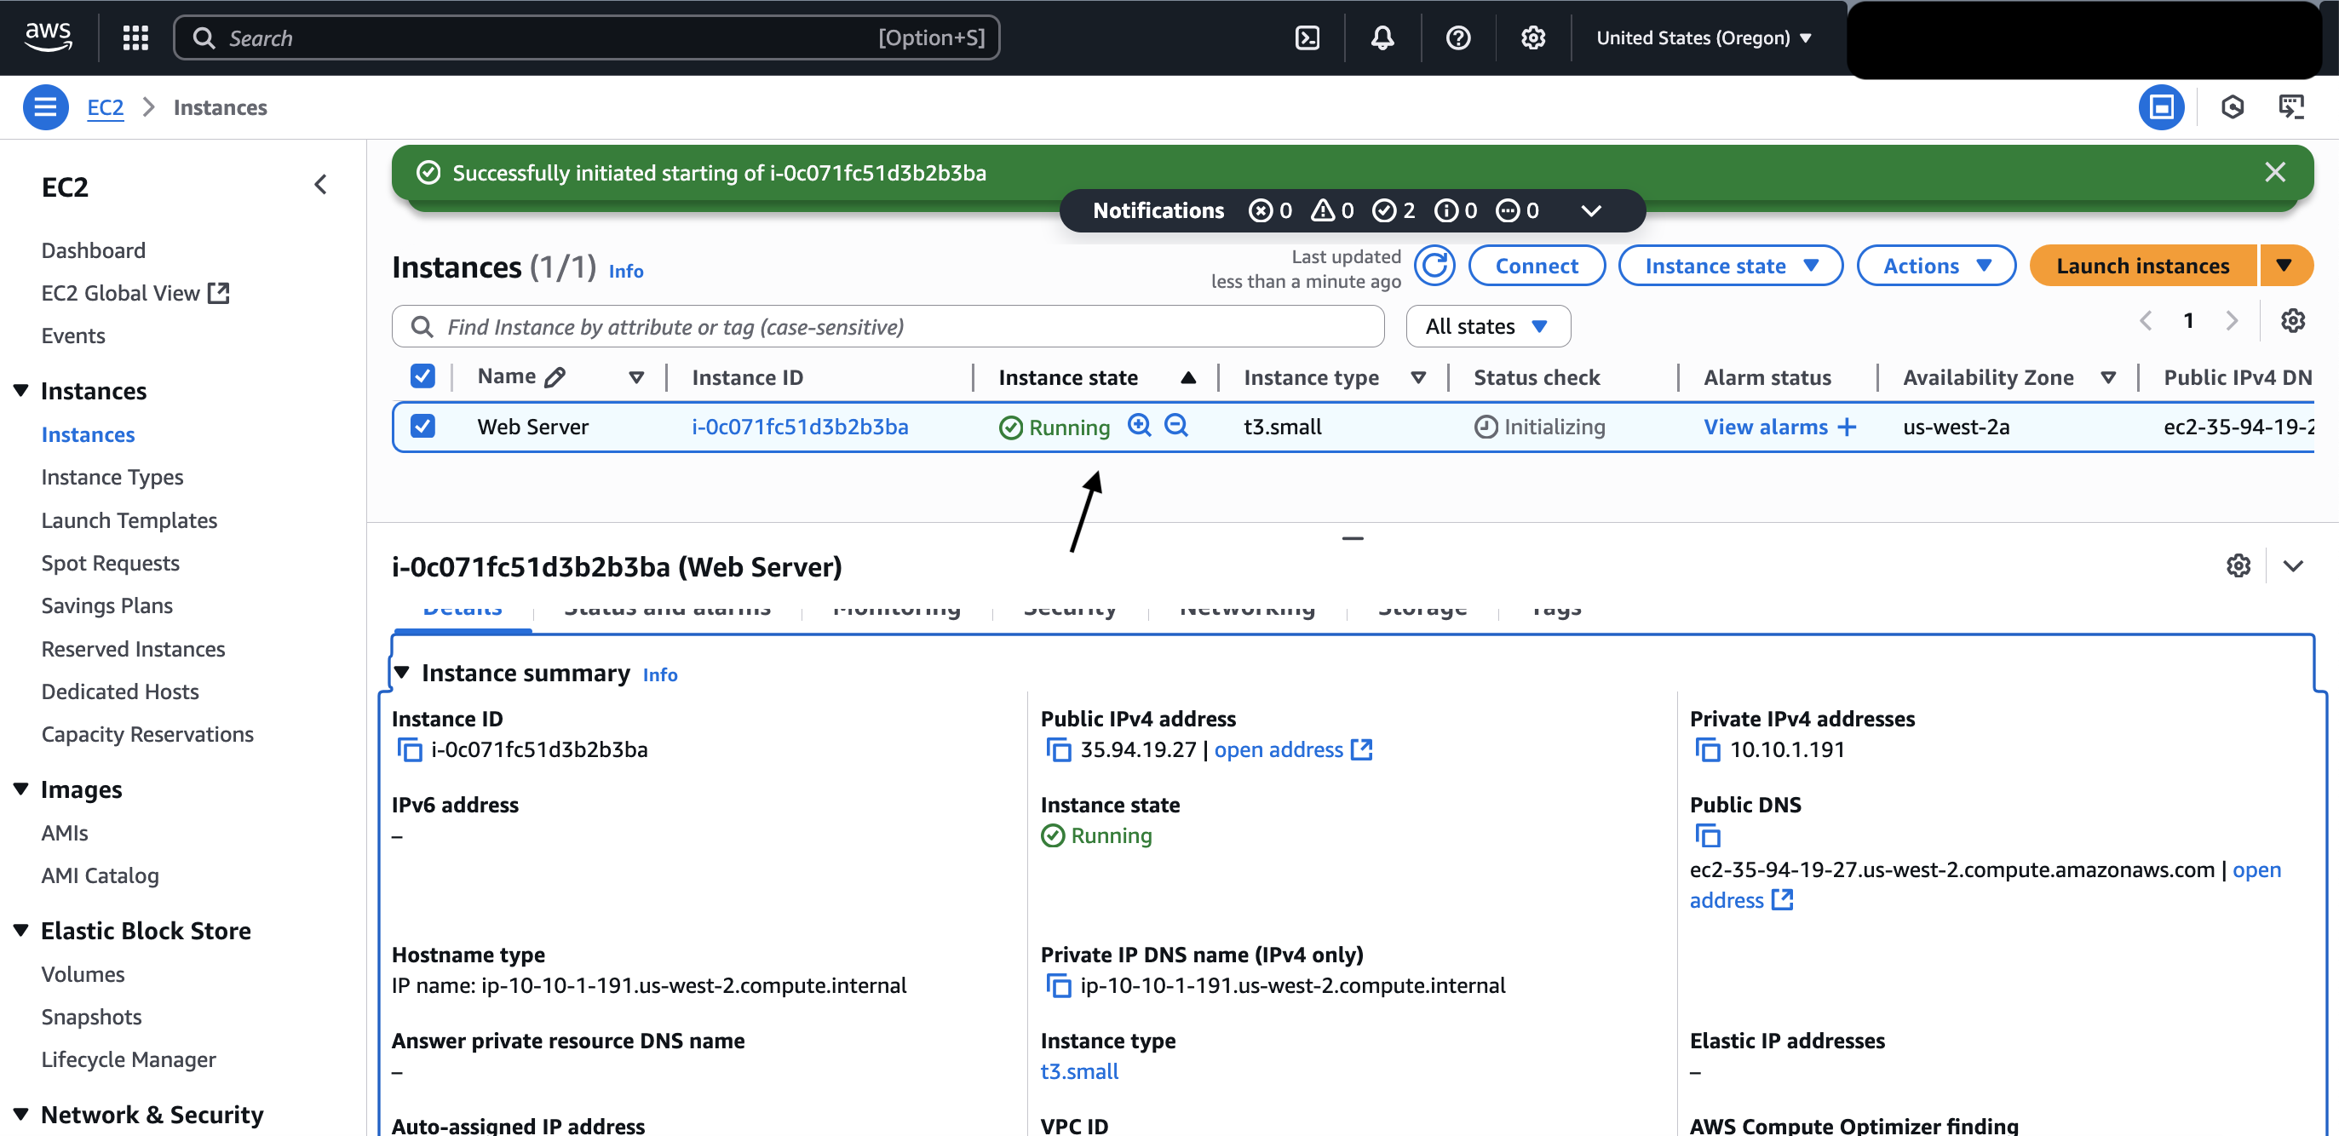

Figure 21: t3. small launch (source: personal collection)

* Step 3: I resized the EBS Volume from 8 GiB to 10 GiB as follows:

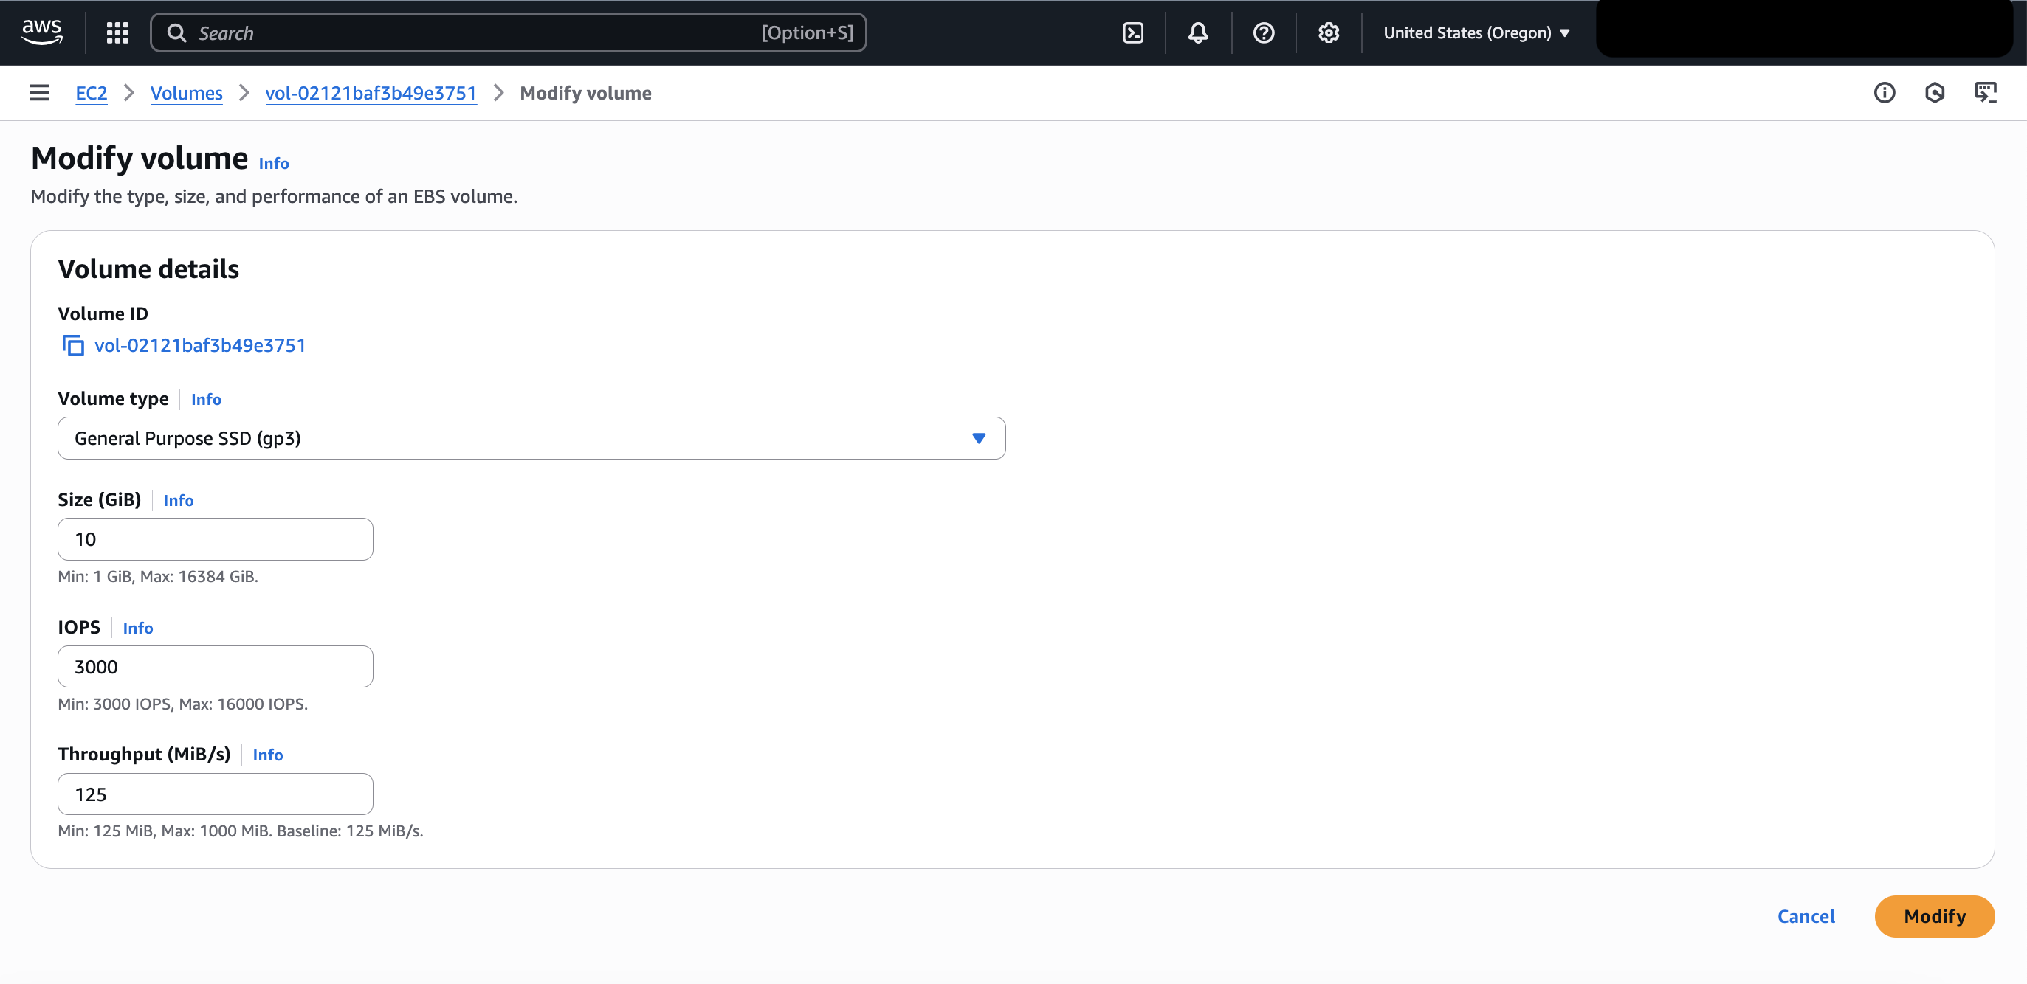

Figure 22: EBS Volume dashboard (source: personal collection)

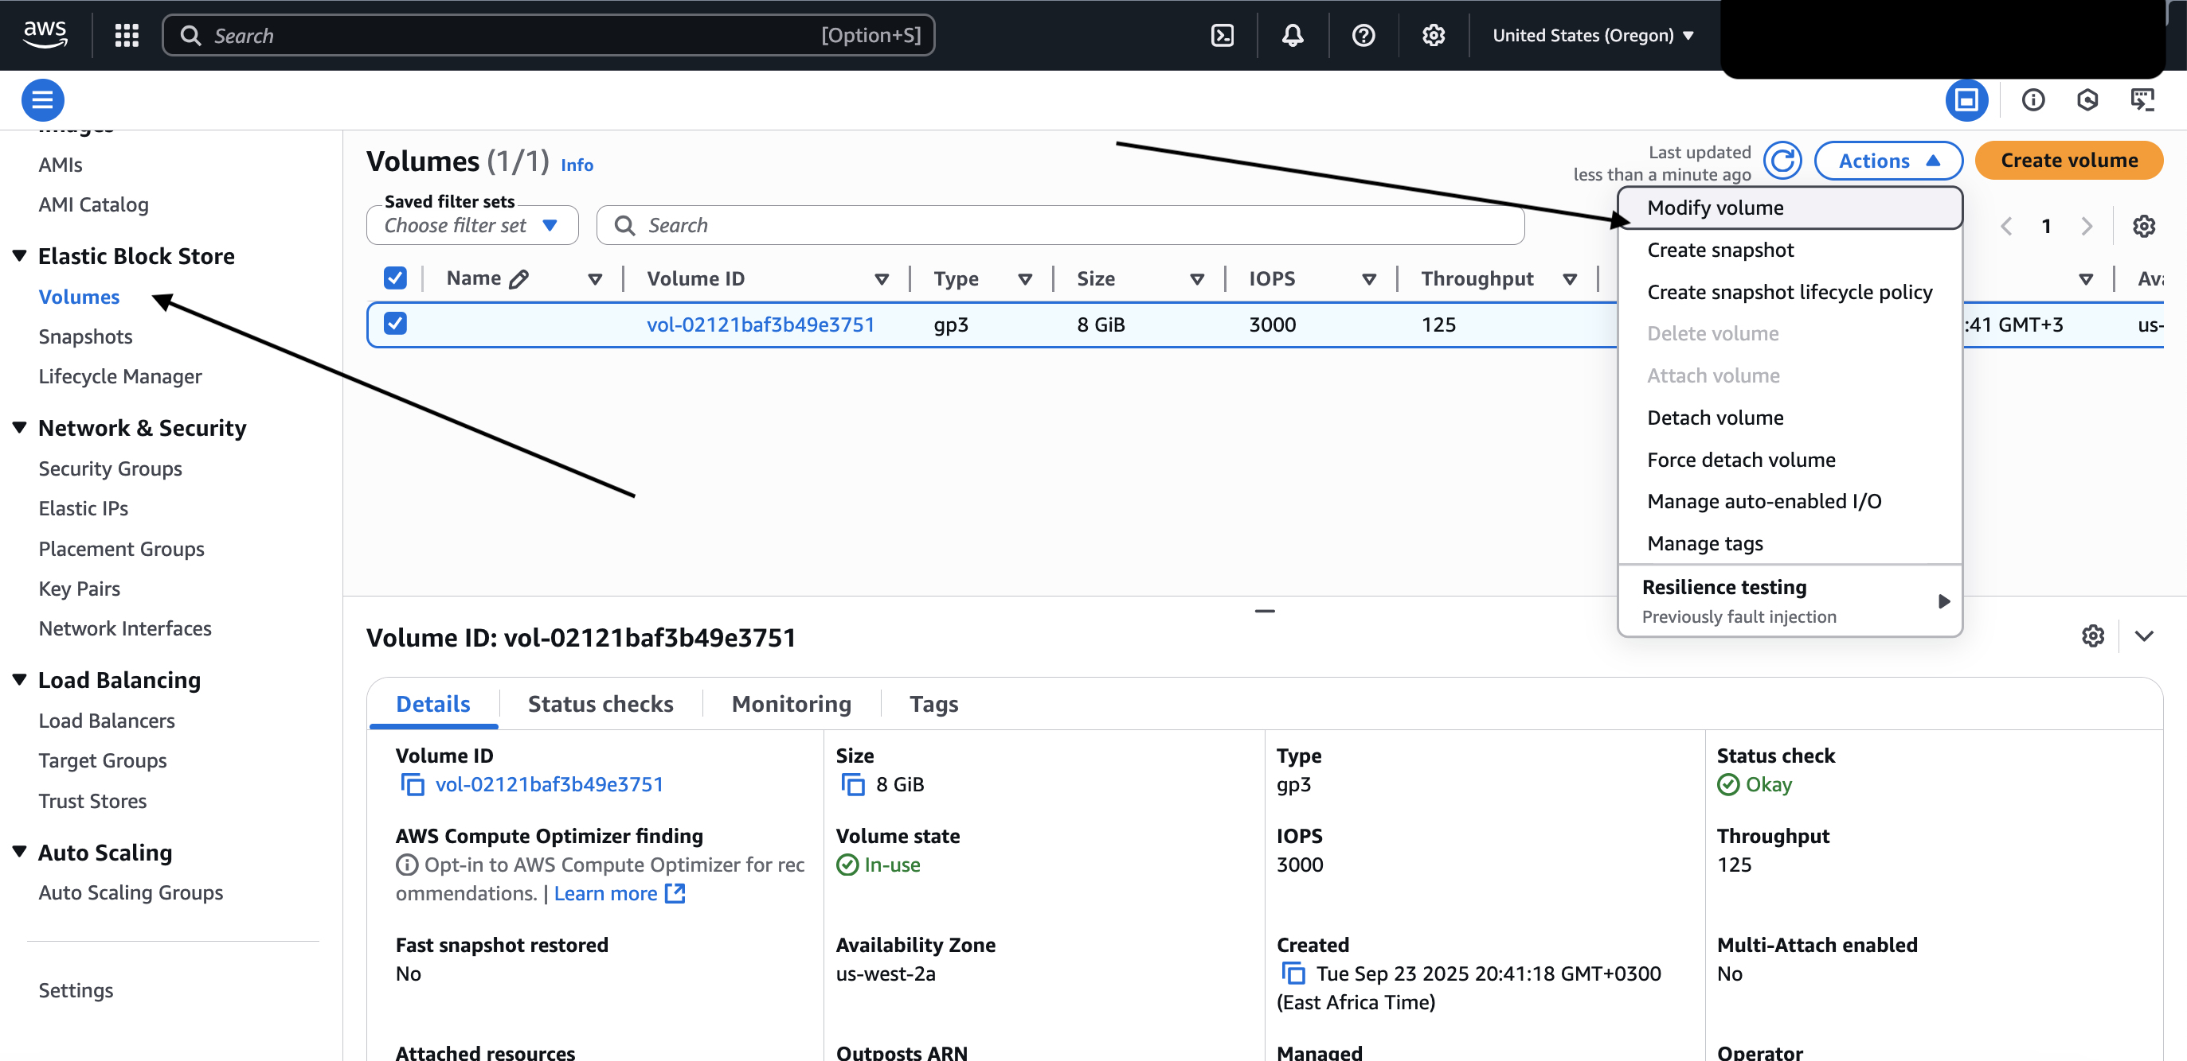

Figure 23: EBS Volume details (source: personal collection)

### Task 5: Test Termination Protection

* Step 1: I disabled the termination protection as follows:

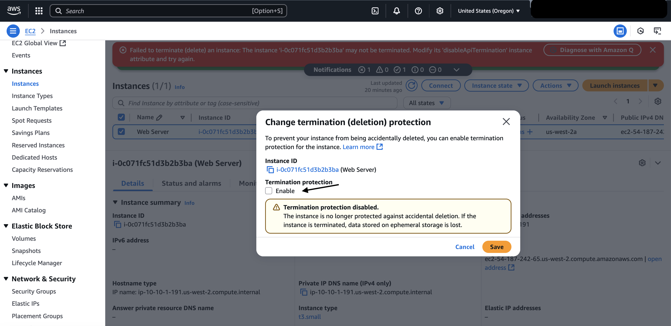

Figure 24: Disabling termination protection (source: personal collection)

* Step 2: From the instance state, I chose the “Terminate (delete) instance” as follows:

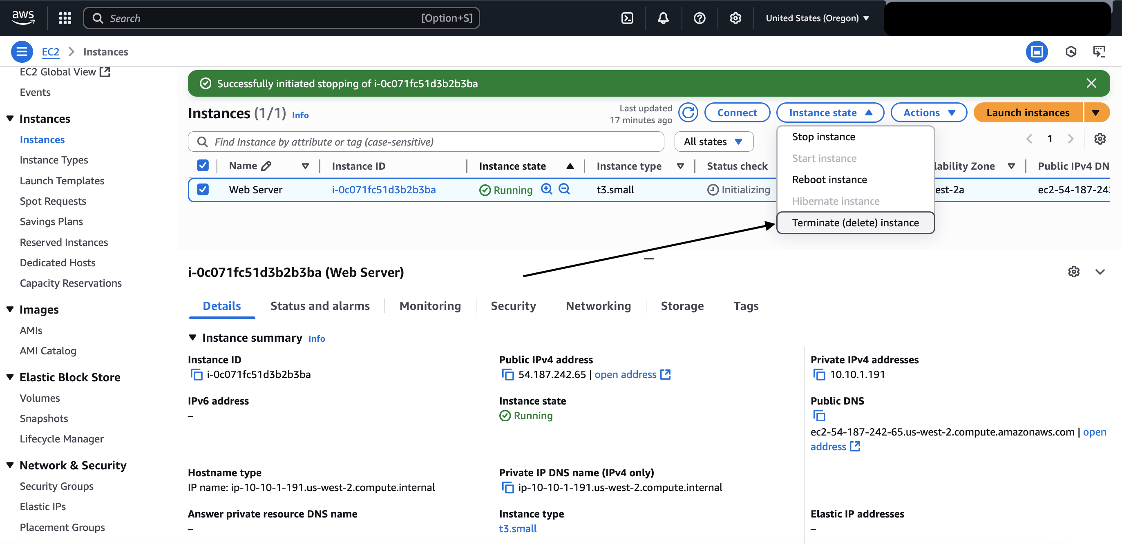

Figure 25: Instance state overview (source: personal collection)

* Step 3: I pressed the “Terminate (delete)” as follows:

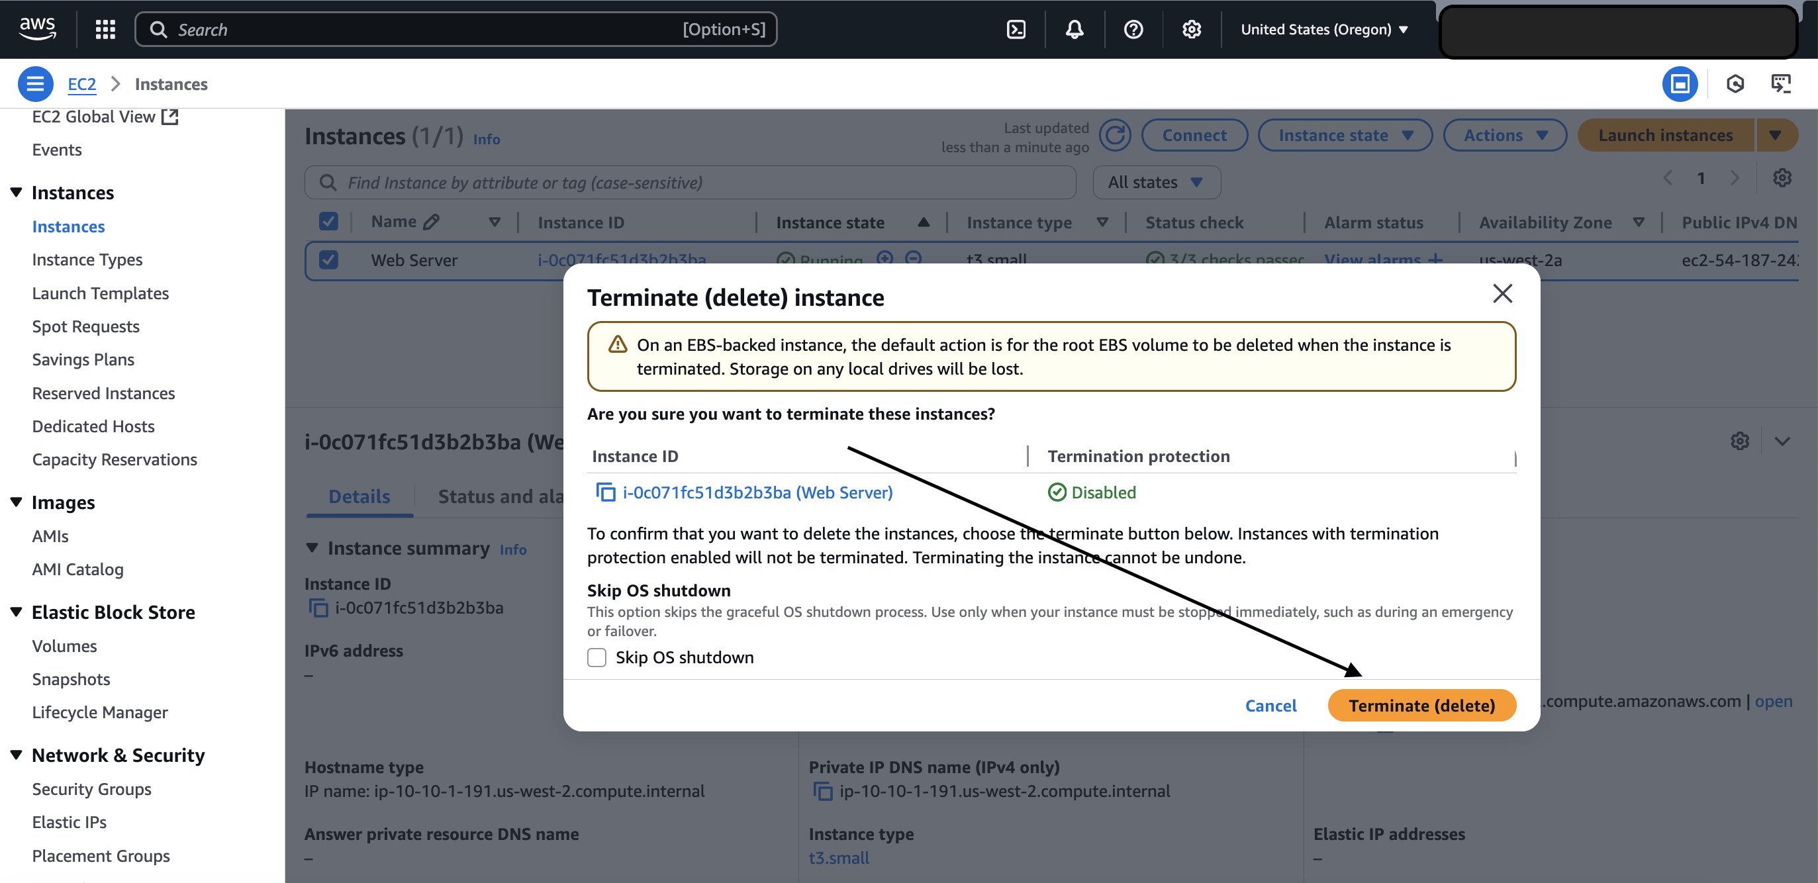

Figure 26: Prompt to delete the instance (source: personal collection)

* Step 4: I waited until the instance was terminated successfully as follows:

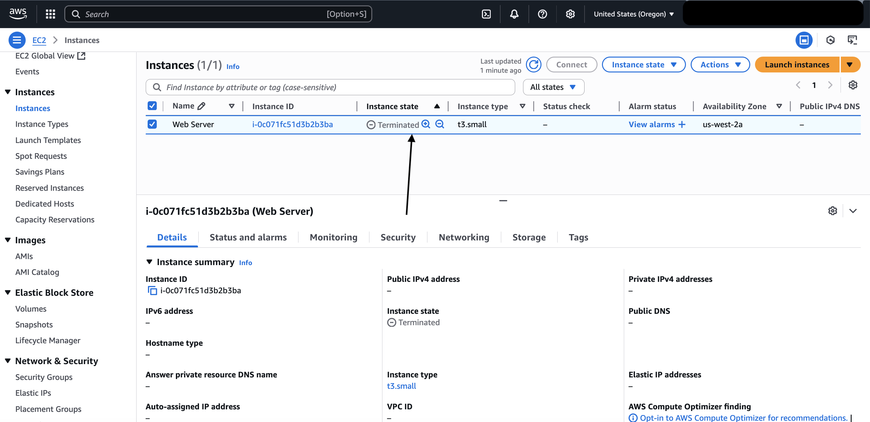

Figure 27: instance terminated successfully (source: personal collection)

### Conclusion

In this lab, I learned the basic overview of launching, resizing, managing, and monitoring an Amazon EC2 instance.

Amazon Elastic Compute Cloud (Amazon EC2) is a web service that provides resizable compute capacity in the cloud (AWS,2025). This is designed to make web-scale cloud easier for developers.

## Reference

AWS Training and Certification. (2025, September 23). *Introduction to Amazon EC2*. Retrieved from <https://lab.builder-labs.skillbuilder.aws/sa/lab/arn%3Aaws%3Alearningcontent%3Aus-east-1%3A470679935125%3Ablueprintversion%2Fspl-200%3A1.3.18-598566d9/en-US>

1.